**CASE STUDY**

**GROUP - 3**

**REVIEW - 1**

**TOPIC: IMDB MOVIE REVIEW ANALYSIS**

**Procedure for scrapping real-time data**

We took the real-time dataset from IMDb website directly - top rated 1000 movies

(Link:<https://www.imdb.com/search/title/?count=100&groups=top_1000&sort=user_rating>)

Our dataset consists of over 1200+ ratings for 5 different top movies - The Shawshank Redemption, The Matrix, Interstellar, Inception, The Godfather.

The tool we used for web-scraping is ParseHub - it turns a website into a spreadsheet or API.

**Steps involved for web-scraping:**

1. Open ParseHub tool and click on ‘New Project’

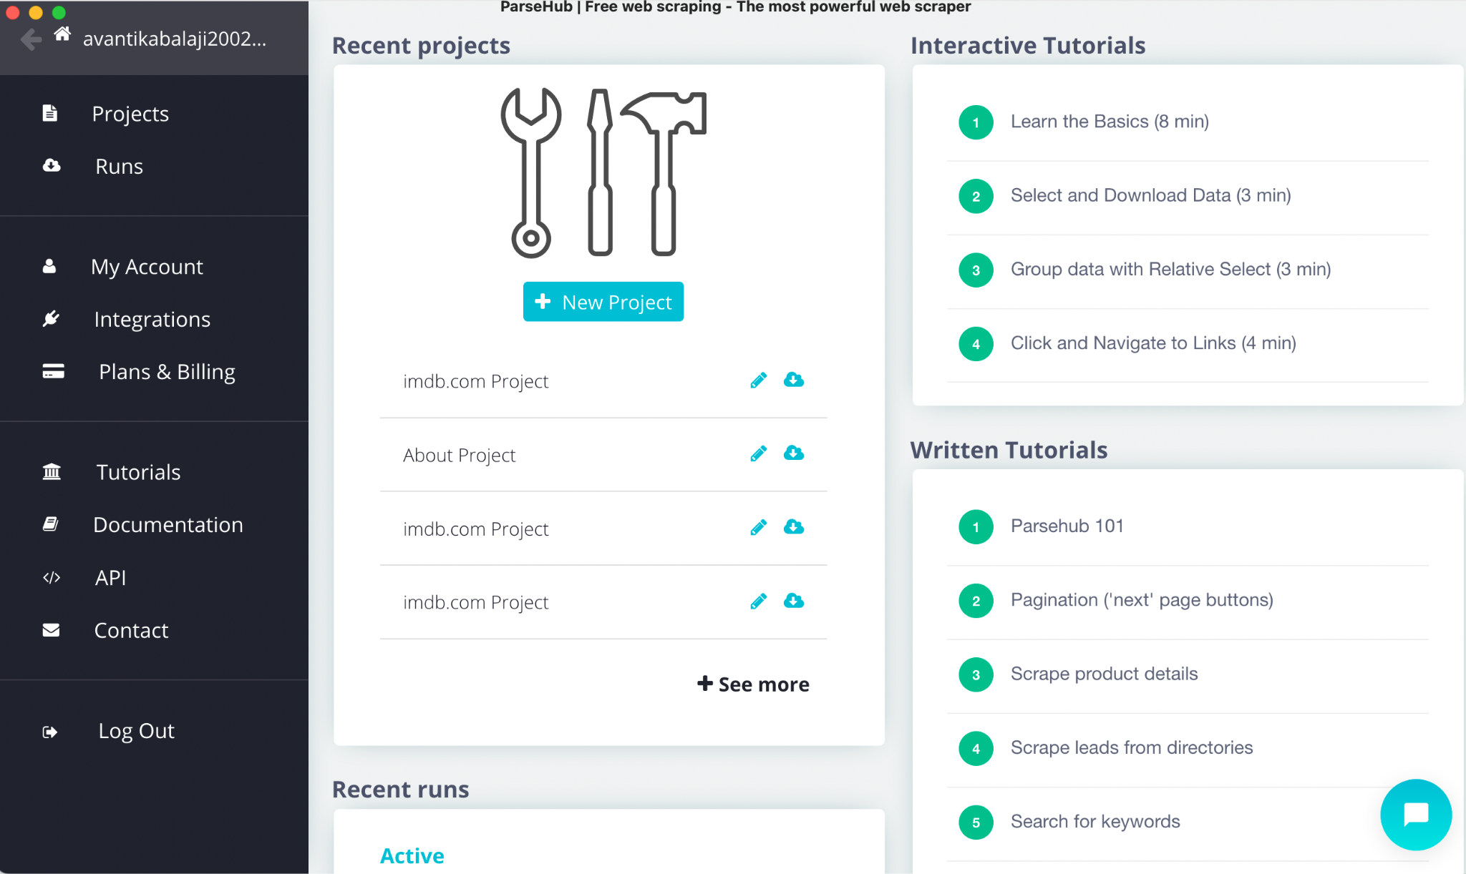



1. Enter movie rating URL in the search bar inside ParseHub

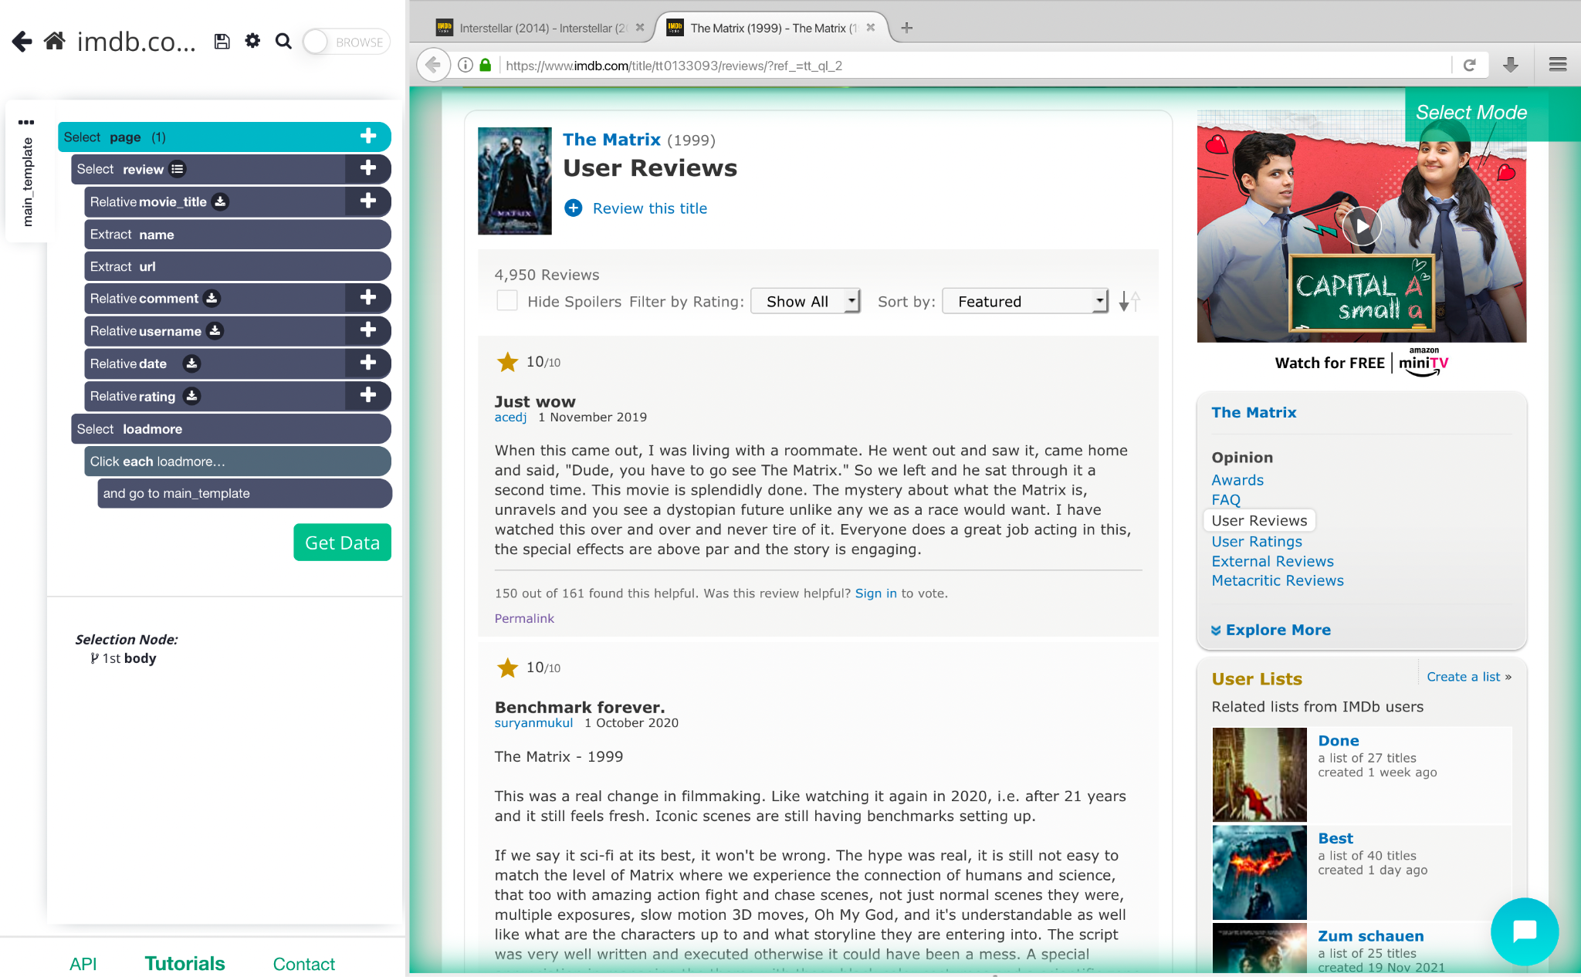

1. Select Page and click on any one or two User Reviews (components), similarly the other reviews are extracted.

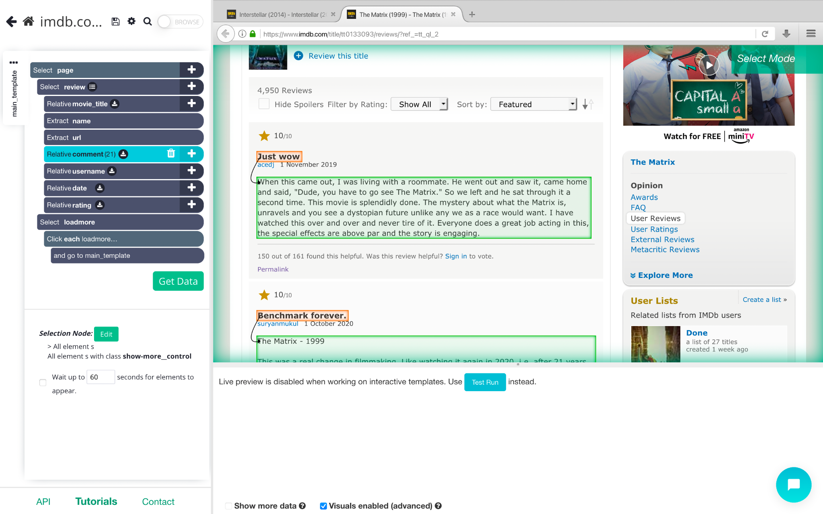

1. Select movie title and URL and draw connection to all the User Reviews under it.

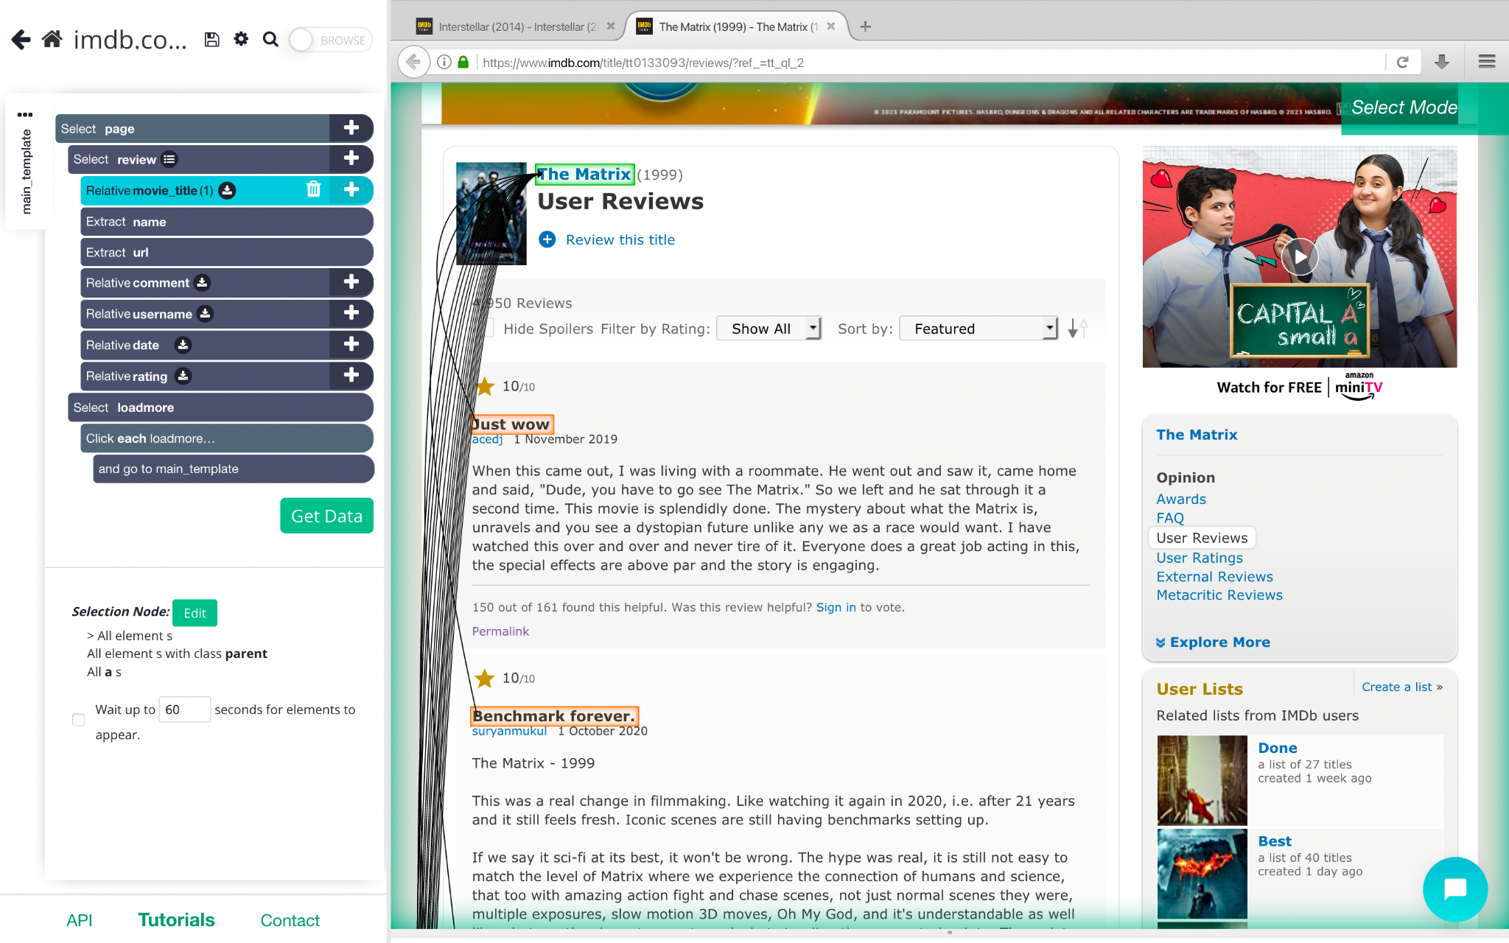

1. Relate each comment to their respective movie review title

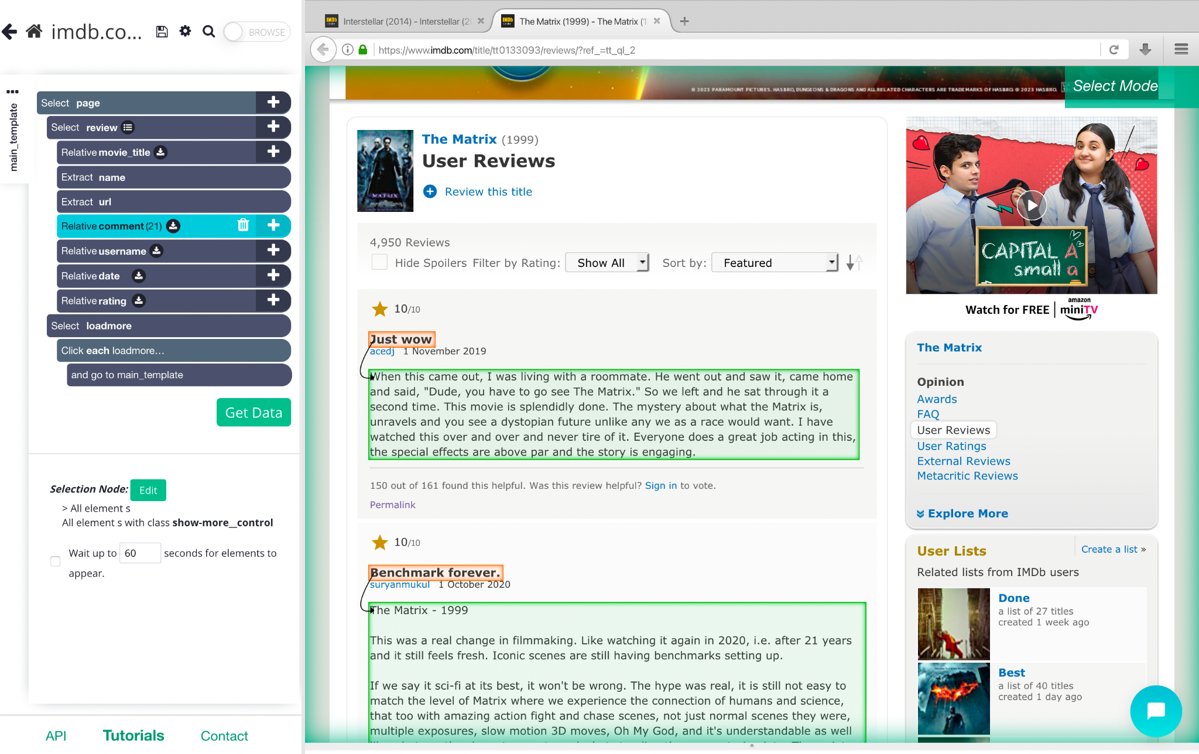

1. Relate each username to the Review Comment

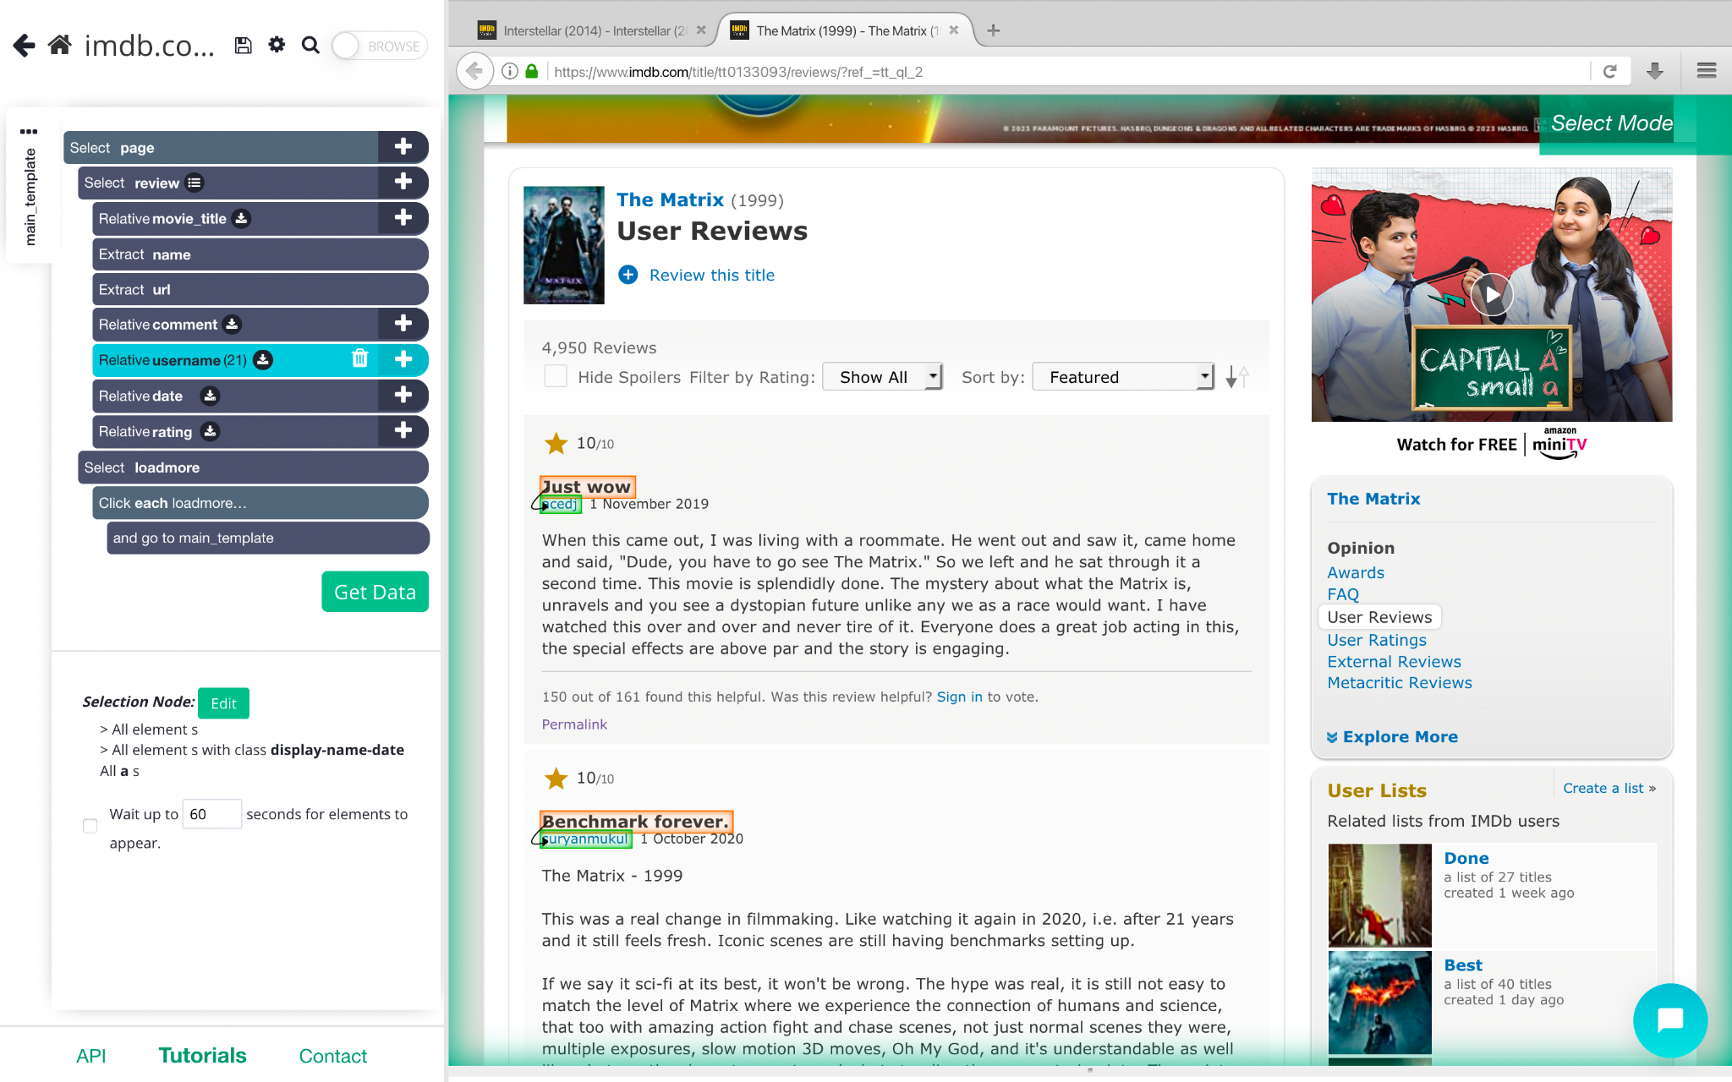

1. Relate the review date to the Review Heading

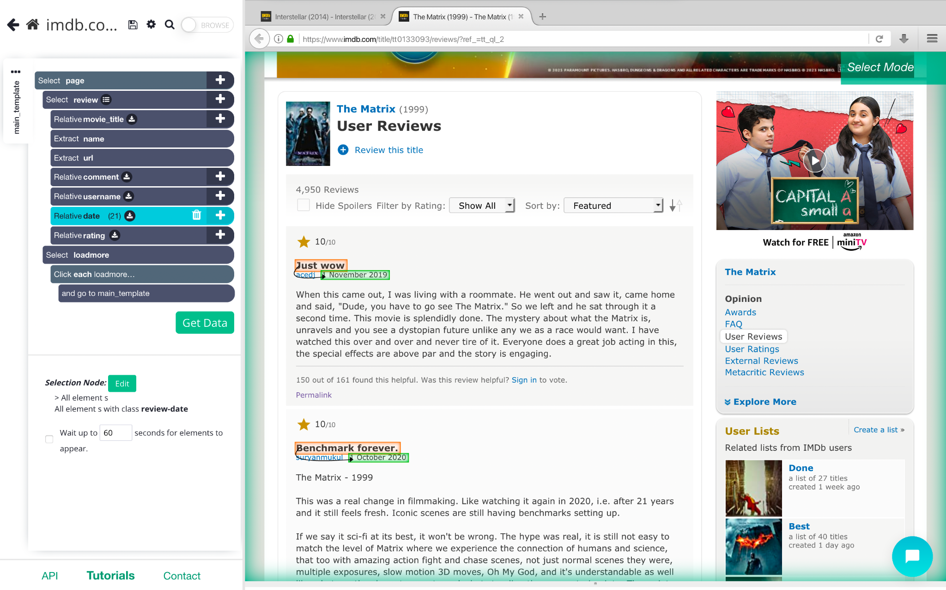

1. Each movie rating is then linked to their respective review

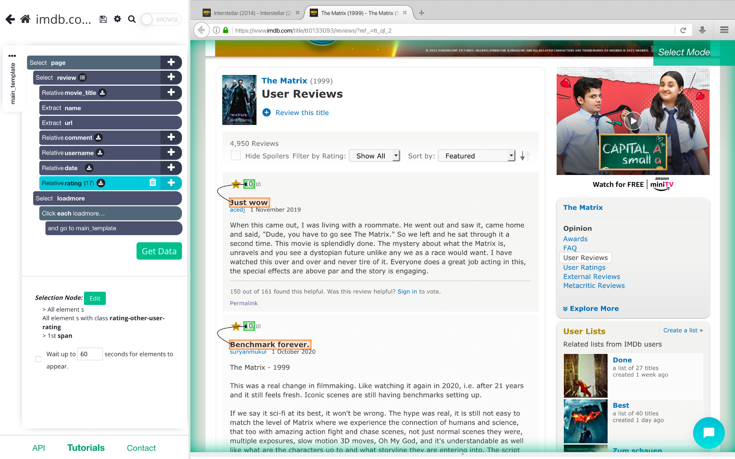

1. Set LoadMore as a button in order to extract reviews from further pages as well

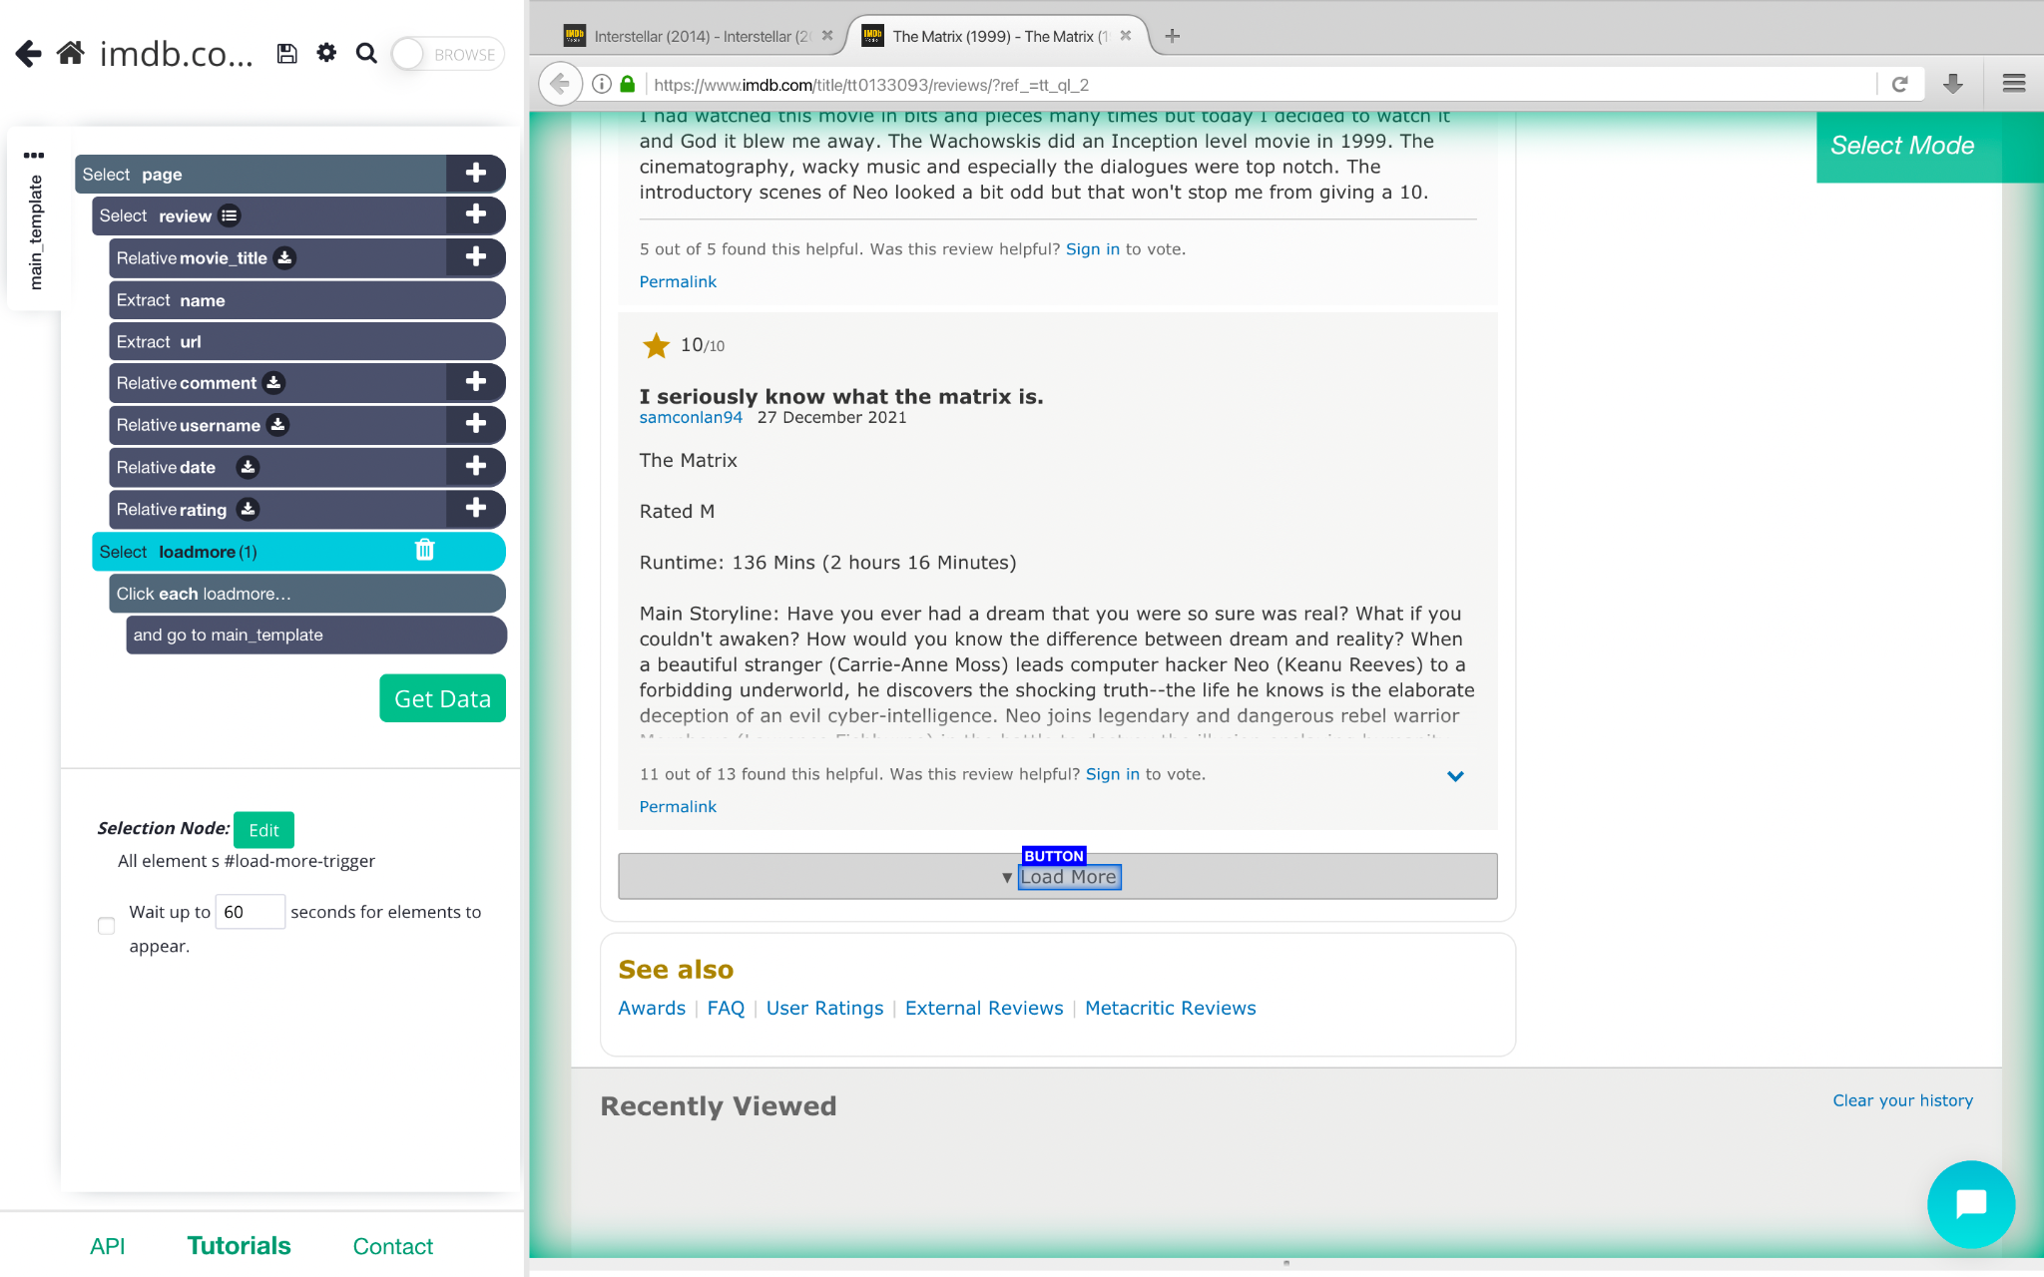

1. Set LoadMore such that it will be clicked 25 times and extract movie reviews from 25 pages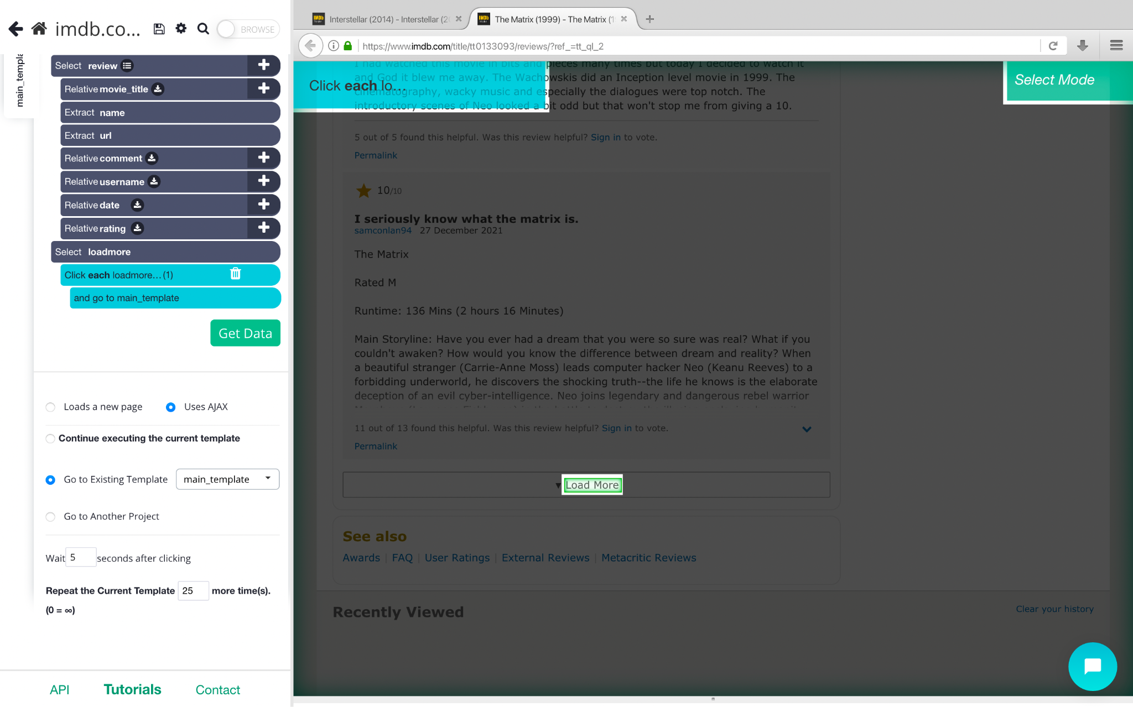
2. Click on Run(Debug) to extract data as CSV/JSON. Each action is repeated for a number of times we wish and the final CSV file with all required columns is generated.

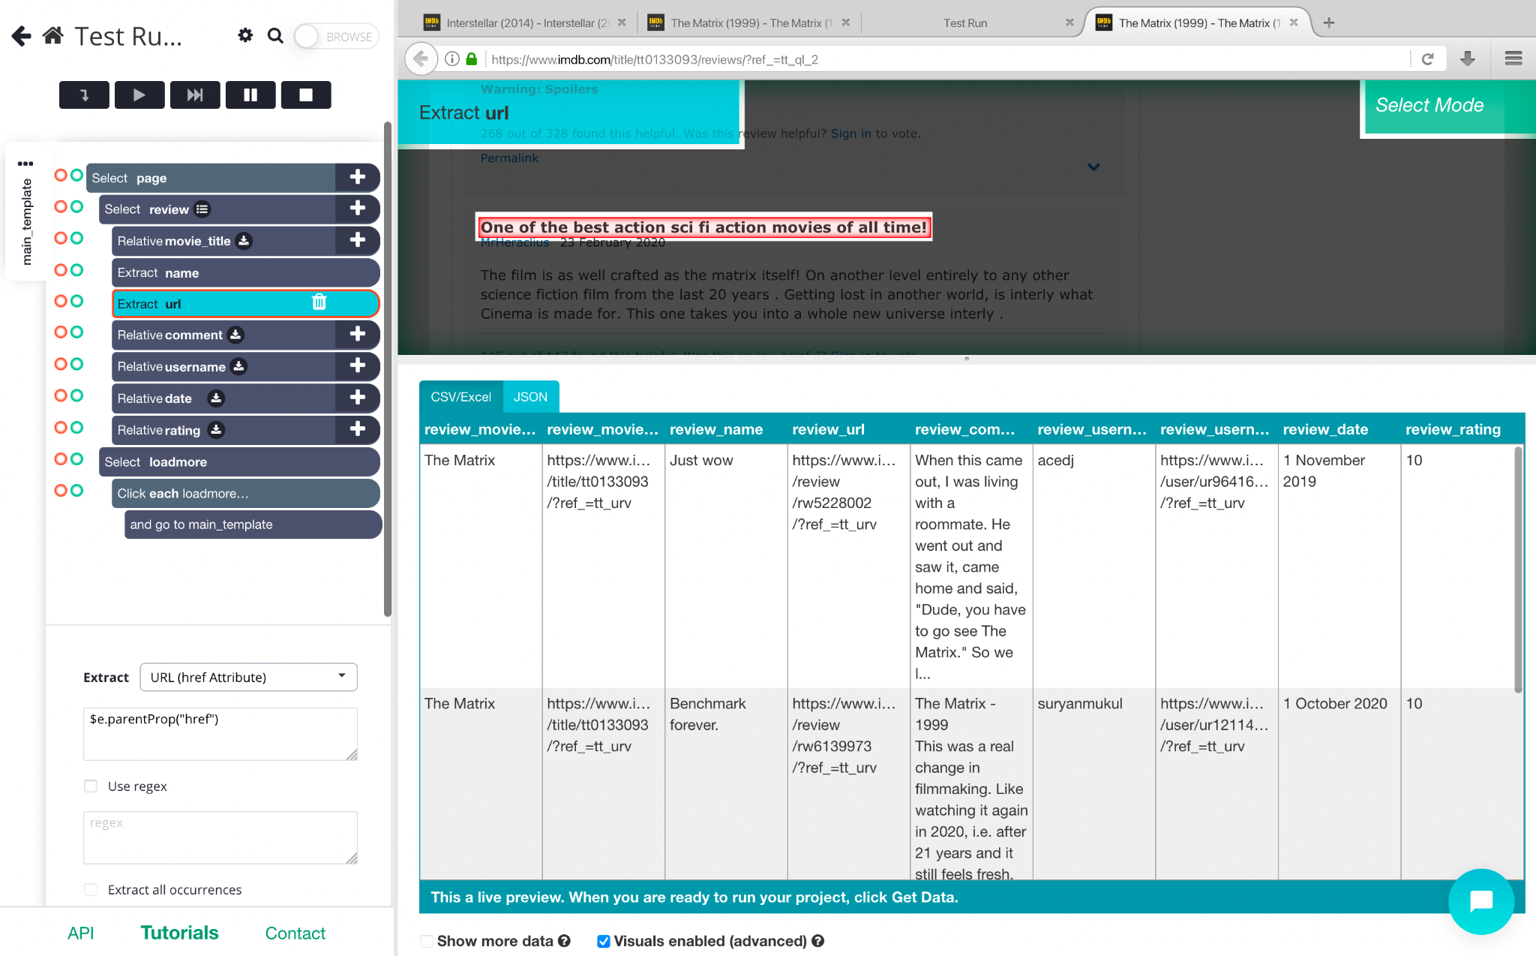

1. The above same process is repeated for all other movies and we get 1200+ reviews for each movie. In this way we have extracted over 14000 user reviews for 5 different movies that amounts to about 10MB.

**Link access to view dataset:**

<https://docs.google.com/spreadsheets/d/1dcuWEicrKu-BLl_tBV6WSG_aF9qvcTIm0Lmo2siNuUI/edit?usp=sharing>